

|  |  |
| --- | --- |
|  | Cummins Quality Management Software (CQMS) - MetricStream  **Supplier Training**  **Version 6.1** |
|  | User Guide |  |
|  |

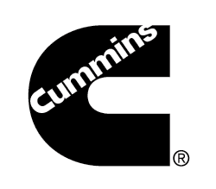

Copyright © 2016 Cummins Inc. All rights reserved.

No part of this publication may be reproduced, transmitted, transcribed, stored in a retrieval system, or translated into any language, in any form or by any means, electronic, mechanical, photocopying, recording, or otherwise, without prior written permission from Cummins Inc.

All copyright, confidential information, patents, design rights and all other intellectual property rights of whatsoever nature contained herein are and shall remain the sole and exclusive property of Cummins Inc. The information furnished herein is believed to be accurate and reliable.

However, no responsibility is assumed by Cummins Inc. for its use, or for any infringements of patents or other rights of third parties resulting from its use.

Table of Contents

1. Introduction 4

1.1. Purpose of This Document 4

1.2. What is CQMS-MetricStream? 4

1.3. Why is Cummins Using CQMS-MetricStream? 4

1.4. Benefits to Suppliers 5

2. Access and Navigation 6

2.1. Gaining Access to the Cummins Environment 6

2.2. Requirements to Use CQMS-MetricStream 6

2.3. Logging In 6

2.4. CQMS-MetricStream Issue IDs 10

2.5. CQMS-MetricStream Assignments 10

2.6. Email Alerts 13

2.7. Exiting CQMS 14

3. Responding to Non-conformances 15

3.1. PNC Supplier Response Form 15

3.2. MNC Supplier Response Form 17

3.2.1. MNC – Supplier Containment Requested 18

3.2.2. MNC – Supplier RMA Requested 20

4. Responding to SCARs 22

4.1. The CQMS-MetricStream Corrective Action Workflow 22

4.2. Completing the ST Form 22

4.3. Completing the LT Form 31

5. Introduction to Reports 38

6. How to Get Help 42

# Introduction

## Purpose of This Document

Welcome to Supplier Training for the Cummins Quality Management Software (CQMS) – MetricStream application. In this guide, you will learn:

* Section 1 – What CQMS-MetricStream is, why Cummins is using it, and how it will benefit you
* Section 2 – How to gain access to and navigate through the system
* Section 3 – How to use CQMS-MetricStream to respond to Material Non-conformances (MNCs) and Process Non-conformances (PNCs) issued against you
* Section 4 – How to use CQMS-MetricStream to respond to Supplier Corrective Actions (SCARs) issued against you
* Section 5 – What reports are available and how to use them
* Section 6 – Where to get help when you need it

## What is CQMS-MetricStream?

Cummins partnered with MetricStream (an external vendor) to create CQMS-MetricStream. It is a web-based software application which was designed to be a Cummins-wide, common solution that enables and facilitates better control of Cummins’ quality processes for non-conformances (material and process) and corrective actions. It is often referred to just as CQMS.

## Why is Cummins Using CQMS-MetricStream?

Customer satisfaction and business results come from the interaction of processes across businesses and functions. These interactions determine the quality of results. Specifically, the quality of results at Cummins means:

* Customers get what they pay for
* Our products are dependable
* Our lead times are short
* Our repair services fix things right the first time
* Our plants deliver the right products on time
* There is no rework in our plants
* Our scrap levels are low
* Our suppliers work with us to fix defects

For key processes, the right way to do the work is the only way to do the work worldwide. The main goal of CQMS-MetricStream is to drive these common processes across all Business Units and Cummins suppliers.

In short, Cummins is using CQMS-MetricStream to help ensure better quality. As a supplier to Cummins, you will be required to register for and use this system when applicable.

## Benefits to Suppliers

CQMS-MetricStream has many benefits to Cummins, such as establishing common data definitions and providing a central framework that falls in line with Cummins IT strategy. However, there are also direct benefits to you as a supplier. Here are just a few examples:

* **Quick access to issues**. When Cummins creates a non-conformance or corrective action that concerns you, you will be notified immediately via system generated email. This improves your ability to respond in a timely manner.
* **The ability to attach supporting documents and comments**. Each time you respond to an issue, you now have the option to comment on it and to attach documents such as scanned photographs for your partners at Cummins to view.
* **Enhanced reporting**. CQMS-MetricStream allows you to see your data by means of supplier standard reports. These tools allow you to better view and control quality measures from a Cummins perspective.
* **Controlled data access**. Using several different layers of IT security, CQMS-MetricStream will only allow you to see data that pertains to you while at the same time protecting this data from being accessed by other suppliers or non-interested parties.

# Access and Navigation

## Gaining Access to the Cummins Environment

CQMS-MetricStream is hosted on Cummins IT equipment, and it requires that all users be on the Cummins Intranet for security purposes. As a supplier, you will be accessing CQMS-MetricStream through the Global Supplier Portal ([supplier.cummins.com](http://supplier.cummins.com/)).

Some suppliers also use the Integrated Supply Chain Management (iSCM) website to gain access to CQMS-MetricStream and other Cummins Quality applications. If you currently use iSCM, you may continue to do so. However, when you click on the CQMS link after logging in to iSCM, the system will automatically redirect you to the Global Supplier Portal. You won’t need to log in again, but once in the Portal, you will need to click on the CQMS link once again which is found under the “My Business Applications” section.

If you have never used iSCM, or have used iSCM in the past *only* to access CQMS-MetricStream and no other applications, you will now log in to the Global Supplier Portal directly by going to [supplier.cummins.com](http://supplier.cummins.com/) and logging in with the Username and Password you created during the registration process.

You need to be properly registered in either the Global Supplier Portal or the iSCM system in order to get access to CQMS-MetricStream.

Note: We will not cover the actual registration process in this document. If you need help or think that you need to be registered but have not been, please email to your Cummins sourcing manager or SQIE for assistance. In your email, please state your name, the company you represent, which Cummins facilities you supply, and a detailed description of your question.

See section 2.3 below for instructions on how to log in to Portal, and then to CQMS-MetricStream.

## Requirements to Use CQMS-MetricStream

The CQMS-MetricStream application is web-based and somewhat data-intensive, and therefore you will need to use a computer with high-speed Internet access.

CQMS-MetricStream was developed specifically for Microsoft’s Internet Explorer browser. All versions of IE through version 11 are certified to work properly. **Other browsers, such as Mozilla Firefox and Google Chrome are not currently guaranteed to work.**

Finally, as mentioned above, you will need to be registered as someone who needs access to CQMS-MetricStream in either iSCM or Global Supplier Portal in order to access the Cummins environment.

## Logging In

Again, if you currently use iSCM for other applications and would like to continue to use iSCM to access CQMS-MetricStream, you may do so. Simply log in to iSCM the way you currently do, and click on the CQMS link. Then, skip to step 3 below.

Otherwise, please follow these steps to log in to the Global Supplier Portal once your registration has been approved:

1. In Internet Explorer, go to [supplier.cummins.com](http://supplier.cummins.com/). When you do, you will see a screen similar to this. Click on the Sign In link in the upper right corner:

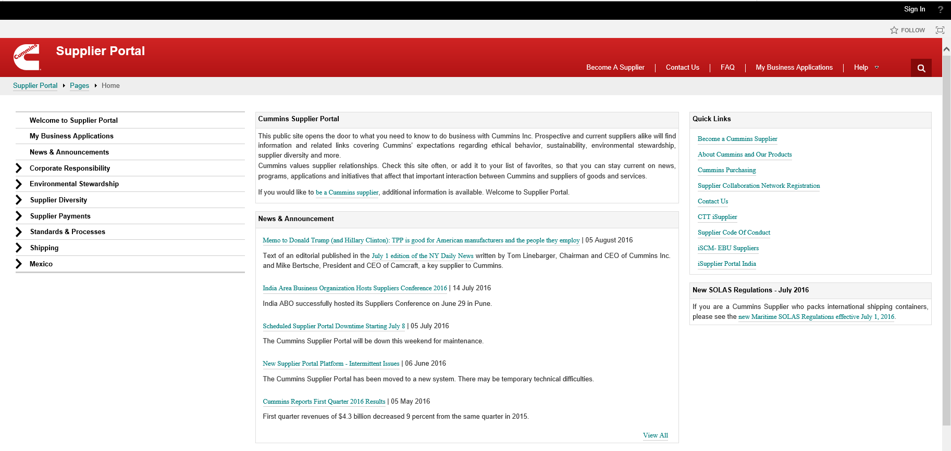

Log In Link

1. Enter your Username and Password as shown below, then click the **Submit** button.

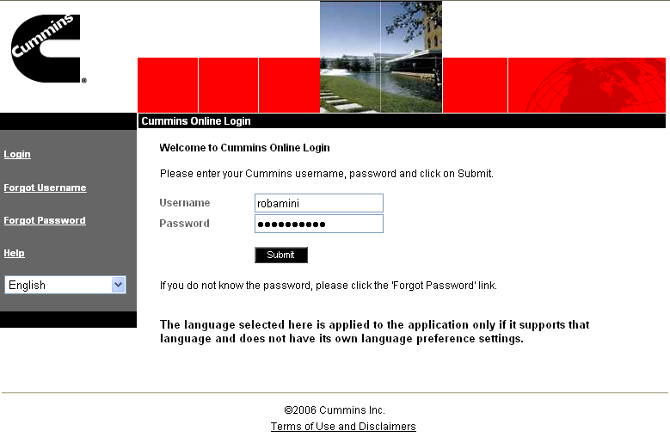

1. Click one of the My Business Applications sections highlighted below and then click the CQMSlink.



Log In Link

My Business Apps – to CQMS & PPAP

Note: In order to use the CQMS-MetricStream application, you need to register and be approved for the Global Supplier Portal, but you also need to be given access to CQMS. These are two separate tasks and may occur at different times.

This means that you may be approved to use the Global Supplier Portal and yet still may not have access to CQMS-MetricStream. This can happen if you supply to a Cummins facility that is not yet “live” with the CQMS-MetricStream application. Don’t worry – you will be able to use CQMS as soon as that Cummins facility comes online (new facilities come online towards the end of the month).

1. Once the system validates you, the CQMS-MetricStream application will appear similar to the screen below. Your name displays in the upper right hand corner. Underneath the MetricStream logo, you will see the main navigation tabs: *MNC/PNC*, *CAR/SCAR*, *My Reports & Charts, Supplier Reports*, PPAP External, SR External and My Reports. You may not see all of these tabs depending on your configuration.

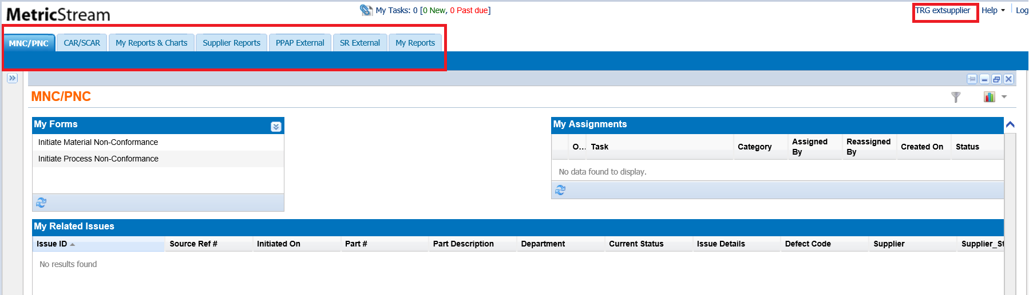

1. You should always use the main navigation tabs, and not the browser’s back and forward buttons, to move around the application. The back button may not display all of the appropriate data correctly. Also, if you ever get “lost” in the system, you can use these main navigation tabs to get back to familiar territory.

There is one final thing you need to know if you are a supplier who has used iSCM to enter NCMRs and SCARs. Again, this only applies if you already use iSCM.

Once a Cummins facility begins using CQMS-MetricStream, from that point on all MNCs/PNCs (formerly NCMRs) and SCARs for that facility will go through CQMS-MetricStream. However, for those facilities that are not yet using CQMS-MetricStream, you will continue to use the iSCM-based SCAR and NCMR links and processes that you do currently.

The screen below illustrates the different links:

Existing NCMRs

## CQMS-MetricStream Issue IDs

Every non-conformance in CQMS-MetricStream has a unique identifier assigned to it. This identifier is known as the Issue ID, and has a format such as **2016-JEP-MNC-00000123**. It tells you the year of the issue, the Cummins site where it was initiated, whether it was an MNC or PNC, and finally the unique number of the issue. This ID stays the same throughout the non-conformance’s lifecycle.

Each SCAR also has its own unique Issue ID, but the Issue ID of the originating MNC or PNC in this case is simply extended (more information about how SCARs are connected to non-conformances will follow in sections 3 and 4). This extension looks like this: **2016-JEP-MNC-00000123-ESCAR-01**. In this example, the term *ESCAR* is used to designate the SCAR as belonging to an external (non-Cummins) supplier. For Cummins facilities who supply other Cummins facilities, the term *ISCAR* is used to designate internal supplier.

Tip: More than one SCAR can be issued from a single MNC or PNC. For example, the first SCAR to be assigned to a third party (external) supplier from the MNC mentioned above would have the Issue ID as **2016-JEP-MNC-00000123-ESCAR-01**. The second SCAR would be **2016-JEP-MNC-00000123-ESCAR-02**, and so forth.

## CQMS-MetricStream Assignments

There are generally two reasons for signing in to CQMS-MetricStream. Either you have some work to do in response to a Cummins issue or you want to run a report. We’ll cover reports later in the guide, but for now, we’ll focus on your responses to Cummins issues. Any response work that you need to do will come to you in the form of an assignment. It is easiest to think of a CQMS-MetricStream assignment as a task or work activity that is waiting to be completed.

You will also receive an email alert when new work is assigned to you and that email will contain directions on how to locate your assignment. Section 2.6 below has more details.

### MNC/PNC Assignments

For material non-conformances (MNCs) and process non-conformances (PNCs), your assignments will be located under the *MNC/PNC* tab in the *My Assignments* & *My Tasks* sections as you see in the screen below:

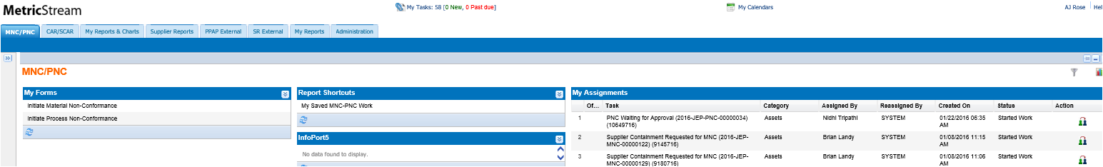

**Supplier Assignments**

**Supplier Assignments**

There are several different types of assignments that you might receive depending on whether the issue is an MNC or PNC, and in the case of MNC whether Cummins has requested a Return Material Authorization (RMA). Regardless of the label, however, all assignments will have the word “Supplier” in them and appear as a hyperlink.

When you click on that hyperlink, you will be taken to the appropriate *Supplier Response* form. These forms are where you’ll actually complete your work. In section 3, you’ll learn more about each type of assignment and each type of *Supplier Response* form.

Underneath the *My Assignments* section, there is a wide section called *My Related Issues*. This is where you can view any open MNCs in the system that are related to you. Although you will use the *My Assignments* section to find your assignments, the *My Related* *Issues* section will give you added visibility into each open non-conformance. As a supplier looking at *My Related Issues*, you will be particularly interested in the *Supplier Status* and the *Supplier* columns as seen here:



You may often notice that one of your MNC/PNC response assignments in the *My Assignments* section is visible, but you no longer can see it in the *My Related Issues* section. This is because Cummins has closed the issue. In CQMS-MetricStream, you can respond to a non-conformance even after it has been closed by Cummins. Among other reasons, this is to accommodate the time it may take to ship the defective material back to you for further analysis.

1. The *My Related Issues* area does not display data in “real-time” – it takes approximately 20 minutes for new or updated items to appear. There is a time stamp that appears in the upper left hand corner of the area that indicates the time that the data is good as of.

If a SCAR is not initiated and you have not responded after 60 days, your assignment will be removed automatically. Refer to sections 3.1 and 3.2 for more information on this 60 day “window of opportunity”.

### SCAR Assignments

SCAR assignments are slightly different than MNC/PNC assignments. Instead of a *My Assignments* section, there is a *My Actions* section that you will not need to use. Also, instead of a *My Related Issues* section, there is a *My CAR/SCAR/PAR* section. This is where you can go to see if you have pending SCAR response work.

In the *My CAR/SCAR/PAR* section, you will see three color codes on rows where they are appropriate. Any date that is highlighted in yellow is coming due, any date that is highlighted in red is past due, and any link that is highlighted in tan is your assignment.

Each row in this section is an issue where you as the supplier are the Respondent (the person responsible for completing the supplier corrective action), but you may not have a current assignment. For instance, if you have completed your work as the Respondent and have submitted both the Short Term (ST) and Long Term (LT) SCAR forms for approval, you will not have an assignment any longer. However in this case, the row still appears in this section because you retain an interest in the issue as the supplier. If you click on any link that you do not have an assignment on, you will be taken to a read-only view of the form. More information can be found in section 4.

A sample of the *My CAR/SCAR/PAR* section is shown here:

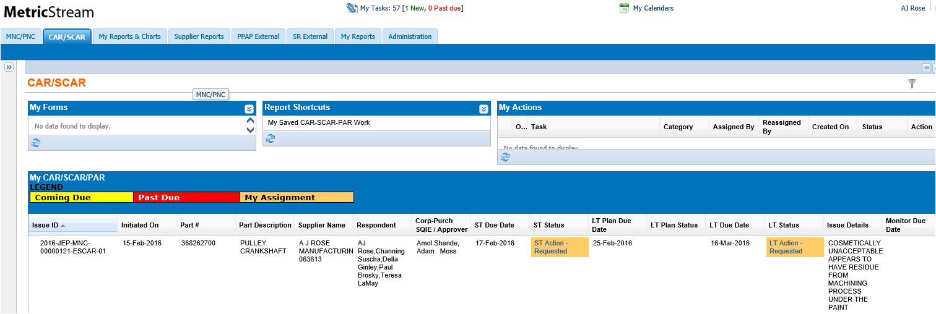

Look for this color to know which SCARs are waiting on you to complete

You will always be the Respondent of a SCAR

All SCARs will have two assignments – Short Term (ST) and Long Term (LT) Actions

All SCARs will have two assignments – Short Term (ST) and Long Term (LT) Actions

Tip: The *My Actions* section in the upper right hand corner will display any work on the ST or LT that you have saved but not submitted for approval yet. You can either click on this saved work under *My Actions* to open the form or use the link under the ST Status or LT Status Column in the *My CAR/SCAR/PAR* section. Both methods launch the same form.

When a SCAR is assigned to you as a Respondent, you will be sent two email alerts, one for ST and one for LT. This is because at your discretion, you may complete the forms in serial or in parallel. The email alerts that you receive will be similar to the email alerts received for an *MNC/PNC Supplier Response* – that is, they will list the exact step-by-step instructions that you should follow to launch the ST and/or LT forms.

These instructions basically tell you to log in to the Global Supplier Portal, to click on the CQMS link, and once in the CQMS-MetricStream application to click on the *CAR/SCAR* tab. Then, use the *My CAR/SCAR/PAR* section to find your appropriate tan colored assignment under the **ST Status** or **LT Status** column, and finally to click on the link to launch the form. You will then be able to complete your assignment (see section 4 for details).

Tip: If you click on any column in *My CAR/SCAR/PAR section*, it will sort the entire report based on that column. Click again to sort in the reverse order.

## Email Alerts

As mentioned above, if Cummins raises a non-conformance or a corrective action that impacts you, CQMS-MetricStream will send you an email alert indicating that you have work assigned to you (in the case of a SCAR, you receive 2 alerts – one for ST and one for LT). The system also sends email alerts at key points in the issue’s lifecycle.

The email you receive will be titled something like “**Cummins QMS: FYI - Material non-conformance issue 2016-JEP-MNC-00000268 Issued**”. In this example, the title indicates that an MNC has been raised where you are the supplier to the Jamestown Engine Plant. It also mentions the Issue ID number (**2016-JEP-MNC-00000268)**. SCAR emails are similar. Here is a sample of what an alert looks like when you open the email:

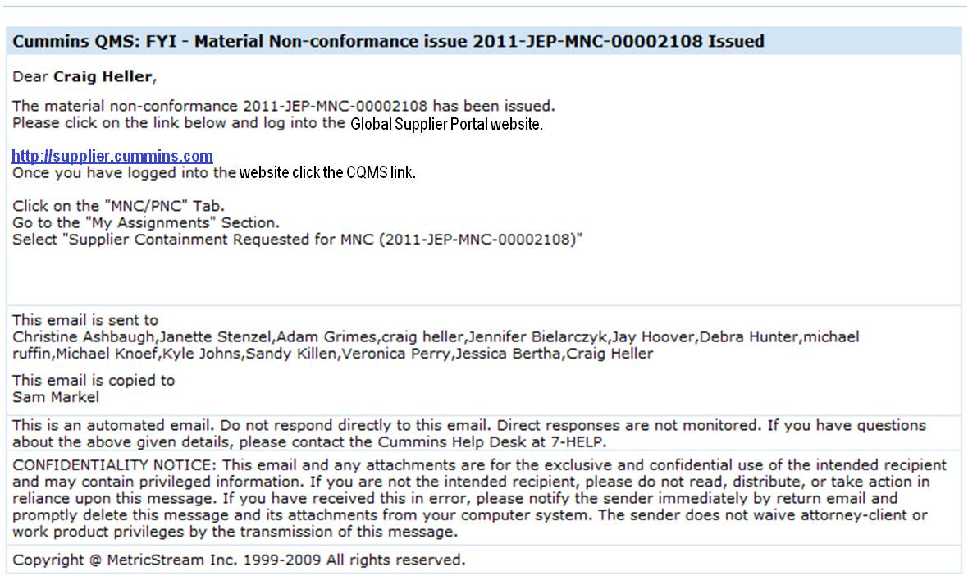

In the body of the email, notice that you are reminded with specific step-by-step instructions to log in through the Global Supplier Portal, click on the appropriate navigation tab, and then click on your exact assignment. As you learned previously, you may still log in to iSCM if applicable.

Be aware that many different people will receive email alerts throughout the various steps of the MNC/PNC and SCAR lifecycles. For instance, the Cummins Corporate/Purchasing SQIE receives alerts at almost every step.

Before we move on to section 3, which shows you how to respond to non-conformances, and section 4, which shows you how to respond to SCARs, there is just one more point to cover.

## Exiting CQMS

Once you have completed your work in CQMS-MetricStream, you can simply exit the application by clicking on the **X** in the upper right corner of your Internet Explorer browser. This will close the window. Unlike other applications, you are not required to logout (There is a Sign out link on Global Supplier Portal).

1. Before you close the browser window, make certain to save any data or it will be lost. There will be no warning, so it is a best practice to get in the habit of saving before you leave CQMS-MetricStream. In fact, as in other software, it is a good idea to save your work periodically to help avoid data disasters.

# Responding to Non-conformances

## PNC Supplier Response Form

A process non-conformance generally occurs when a process no longer complies with a set of standards. Examples include a part that is packaged incorrectly, or a part that is shipped without a proper Advanced Shipping Notice, or an audit finding. Basically, any non-conformance that is not related to a defective part is a PNC.

When a PNC is issued and then approved (validated), only then will you receive an email alert. As discussed above, you will also receive an assignment that you will able to view under the *My Assignments* section of the *MNC/PNC* tab. When you click on this assignment, CQMS-MetricStream will open the PNC Supplier Response form, as you see here:

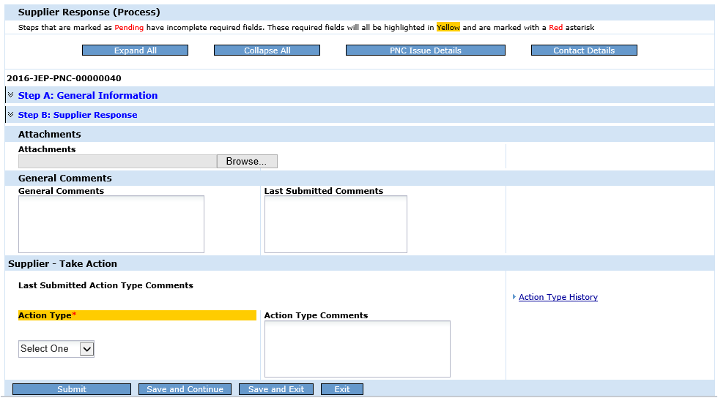

**Expanded Steps A & B**

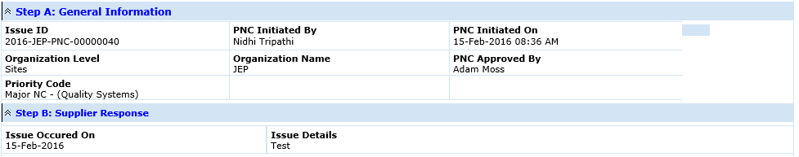

At the top of the form, there are several buttons. First, the Expand All button simply expands both Steps A and B together while Collapse All does the opposite. Next, the PNC Issue Details button allows you to view the entire PNC. Finally, the Contact Details button displays a report that shows who at Cummins approved the PNC along with their email address.

Underneath the buttons is the Issue ID, and beneath that is the collapsible area. On the PNC Supplier Response form, there are only two sections. Step A displays some basic information about the PNC. Step B displays when the issue occurred and the details of the issue. Remember, if you need more information than is available in these two steps, you may click on the PNC Issue Details button at the top of the screen. Both Step A and Step B are shown in blue, indicating that they are optional. If either step had any incomplete mandatory fields in them, they would be shown as red text with the word **(Pending)** at the end.

Beneath the collapsible area are the *Attachments* section, the *General Comments* section, and the *Take Action* section. The *Attachments* section is where you may place any related documents that you wish to share with Cummins. You may do so by using the Browse button. As soon as at least one file is attached, everyone who views this form afterwards will see the *Attachments History* link. This link displays an audit trail of who created (or deleted) what attachments and when.

Note: You may attach multiple files, but you must do it one at a time. Files of any type are allowed, but standard file types (i.e. .jpg, .xlsx, .docx) are encouraged to ensure that Cummins can view them. Finally, although there is not a file size limit, please be cautious not to attach very large files (over approximately 10 MB).

*General Comments* is where you can type in anything you want Cummins to see. As you might expect, the *General Comments History* link will show you the audit trail of any past comments by any party. Similar to the *Attachments History* link, the *General Comments History* link only appears after someone puts a comment in. Initially, the link is not shown. Also note that there is a Last Submitted Comments field. This is for your convenience so that you don’t need to look in the *General Comments History* link if you don’t want to. General Comments cannot be edited or deleted after the Submit Button has been pressed.

Finally, at the bottom of the form, the *Take Action* section gives you two choices in the drop down: **Acknowledge** or **Dispute** (technically, there is a third option which is to do nothing at all – in this case, your inaction will not stop the Cummins workflow, but Cummins would still prefer you to complete this task by acknowledging or disputing the PNC). Notice that this is the only mandatory field on the form.

In this section there is also an Action Type Comments field. As you learned above, if you have comments for Cummins, they normally go in the *General Comments* section. By contrast, this field is specifically for you to enter in comments if you need to dispute the issue as described below. An area that shows the Last Submitted Action Type Comments as well as an *Action Type History* link can also be seen.

The buttons at the bottom of the form are as follows:

* **Submit** – sends your acknowledgement or dispute to Cummins, depending on what you have chosen.
* **Save and Continue** – saves your work (a good idea, especially if you need to take a break from your computer for a short time) and leaves the form open.
* **Save and Exit** – saves your work but closes the form. This is useful if you are not going to be using the system for an extended period of time, such as if you’re going to lunch or leaving work for the day.
* **Exit** – does not save your work, but simply closes the form. A warning will appear reminding you to save if you haven’t done so already. You will be taken back to the *MNC/PNC* tab.

### Acknowledging a PNC

When you select **Acknowledge** from the *Action Type* field and click **Submit**, CQMS-MetricStream sends an email alert to the Cummins user who approved the PNC as a valid issue and notifies them of your acknowledgment.

Note: Even after your acknowledgment, your CQMS-MetricStream assignment remains open and still displays in your *My Assignments* section for 60 days after the date that the PNC was approved on. Within this time frame, you may still **Dispute** the PNC despite your earlier acknowledgment. The reason for this allowance is that you may not immediately have enough evidence to dispute, but if that evidence surfaces, Cummins gives you the ability to correct your response. After 60 days, CQMS-MetricStream will remove the assignment from you.

1. The only exception to this 60 day period is the situation where Cummins issues a SCAR. In this case, as soon as the SCAR is issued, CQMS-MetricStream immediately removes the Supplier Response assignment from you. If you still need to dispute, you will do so through the SCAR itself (see section 4 in this training guide).

### Disputing a PNC

If you select **Dispute** from the *Action Type* field, the *Action Type Comments* field becomes mandatory (you should enter the reasons that you are disputing the issue in this field, not the *General Comments* field).

As soon as you click **Submit**, CQMS-MetricStream sends an assignment to the Cummins user who approved the PNC as well as an email alert which notifies them that you have disputed the PNC. That person then can either **Accept** or **Reject** your dispute.

If your dispute is accepted, then Cummins will take appropriate action to remove your assignment and your connection to the PNC. If your dispute is rejected, you will receive an email notification to that effect. In this case, you may add additional comments/attachments and respond appropriately. If you decide to re-dispute you may wish to contact Cummins to discuss the issue. Unless Cummins accepts your dispute, your assignment remains open for 60 days or until a SCAR is issued as you learned above.

Tip: Although for the most part you will want to log in to CQMS-MetricStream only after an email alert has notified you that you have work to do, you may log in at any time at your convenience. When you do, you can always check the *My Assignments* section to see if any assignments are with you.

## MNC Supplier Response Form

The process you will use to access the *MNC Supplier Response* form is the same as for the PNC described above. Once you click on the appropriate link under *My Assignments*, you will be taken right to the form. Unlike PNC, however, there are two different kinds of assignments that you can receive for MNC.

If Cummins requests an RMA, you will receive a type of assignment that reads something like “**Supplier RMA Requested for MNC (2016-JEP-MNC-00000121)**”. If not, you will receive another type of assignment called containment. In this case, the assignment will read something like “**Supplier Containment Requested for MNC (2016-JEP-MNC-00000122)**”. This is illustrated below:

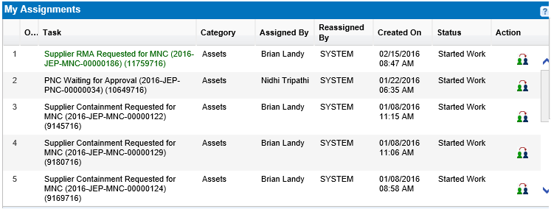

Sample MNC Response where RMA is requested

Sample MNC Response where RMA is not requested

## MNC – Supplier Containment Requested

If you click on a containment type of link, you will see the following form:

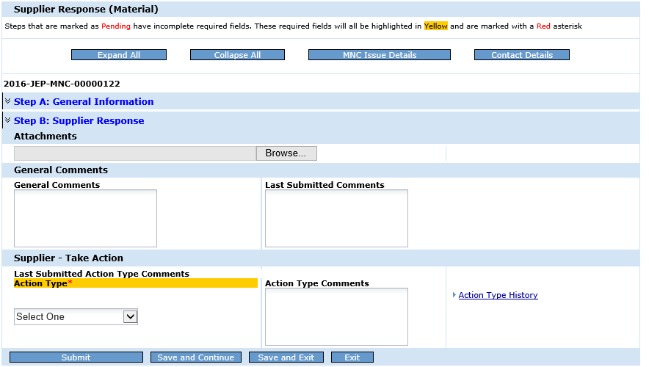

You’ll notice many similarities between this form and the *PNC Supplier Response* form you learned about earlier. In fact, it looks virtually identical. All of the buttons are the same on the top, except that the third button is now *MNC Issue Details*. The Issue ID now refers to an MNC instead of a PNC, but everything else looks the same. As you’ll see in a moment, however, there are some key differences under the surface.

Note: In this example, no one has attached a file or made a General Comment or an Action Type Comment. Therefore, no Attachments History link or General Comments History link can be seen. Notice that no file exists for you to click on in the *Attachments* section, and there is nothing in the Last Submitted Comments field in the *General Attachments* section. Also, there is nothing shown under the Last Submitted Action Type Comments area in the *Take Action* section. Finally, you should be aware that the Action Type History link is shown because Cummins took an Action Type to send it to you, and therefore a history does exist.

One of the key differences is Step B. As you can see below, there are several new fields displayed – Part #, Part Description, RMA #, and MNC Containment.

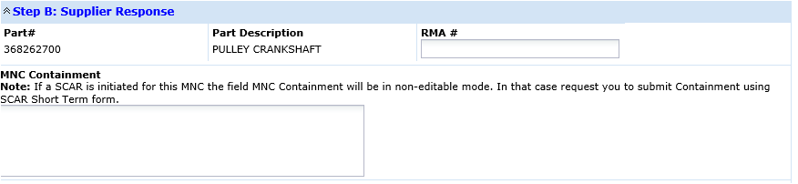

If Cummins has not requested an RMA, then you are not able to type in the RMA # field. However, all of the steps you have taken to protect the customer should be detailed in the MNC Containment field. One thing that you should be aware of is that although the MNC Containment field does not appear as a mandatory field, it will become one if you choose **Send MNC Containment** from the Action Type field. Here’s what Step B will look like after you choose **Send MNC Containment**. Notice that the MNC Containment field has a red asterisk (*) and is highlighted in yellow. Also, the Step B text is red with the word **(Pending)** attached to the end. As soon as you type some text in the MNC Containment field and move on, Step B will turn blue in color and the word (Pending) will be removed.

Finally, there is an important note which states that if a SCAR is raised against this MNC, then you will need to record containment through the SCAR instead of by responding to this MNC. In this case, you will only be able to see this form if an RMA has been requested AND a SCAR is raised. If an RMA is not requested and a SCAR HAS been raised, you won’t see this form.

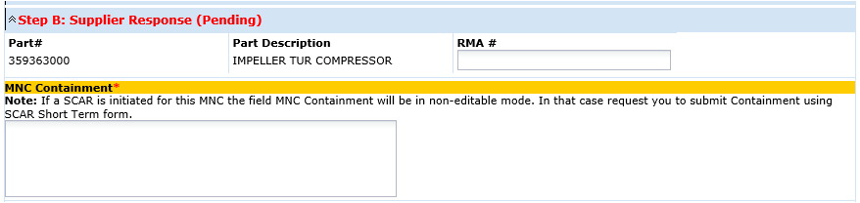

The *Take Action* section is also different from a PNC. It contains two possible selections – **Dispute** or **Send MNC Containment**. Notice that there is no Acknowledge option – your selection of **Send MNC Containment** provides that acknowledgment automatically.

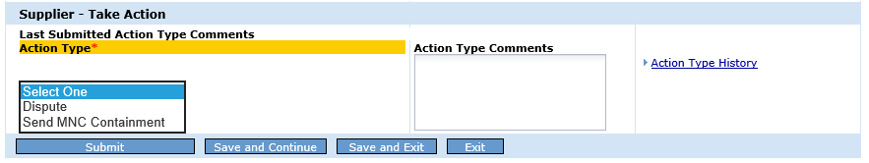

## MNC – Supplier RMA Requested

If Cummins requests an RMA and you click on the RMA Requested assignment, you will see the same form as if you had clicked on a Containment Requested assignment as shown above. However, the Action Type field in the *Take Action* section is now different. Depending on what you choose, Step B will behave differently. Take a look at your choices in the Action Type field:

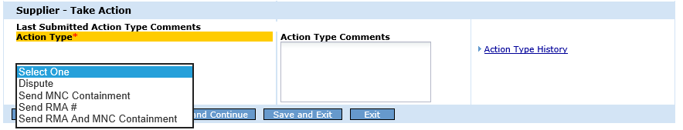

In addition to the **Dispute** and **Send MNC Containment** options you saw previously, you now have **Send RMA #** and **Send RMA and MNC Containment**. As you know, if you choose **Send MNC Containment**, the MNC Containment field in Step B becomes mandatory. If you choose **Send RMA #**, Step B will look like this:

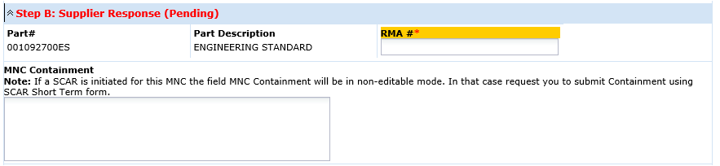

If you choose **Send RMA and MNC Containment**, Step B looks like this:

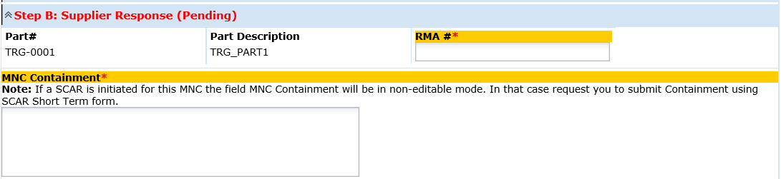

Unless you select **Dispute** as your Action Type, your assignment will remain open for 60 days, similar to how the PNC assignment works. This allows you to dispute the MNC at a later time – for example, after you receive and examine the part.

Note: Remember that if a SCAR has been raised, the **Send MNC Containment** and the **Send RMA and MNC Containment** Action Types as well as the **Dispute** Action Type will not be available for you to choose. If you need to dispute after a SCAR is issued, you need to do so through the SCAR itself (see section 4 below for more information). In addition, containment will be entered in the Short Term Form of the SCAR and the MNC Containment field on the Supplier Response form above will be disabled.

# Responding to SCARs

## The CQMS-MetricStream Corrective Action Workflow

At its simplest level, a supplier corrective action in CQMS-MetricStream is comprised of the following steps:

SCAR Workflow

In sections 2 and 3, you learned how to respond to an MNC or PNC using *Supplier Response* forms. Those forms actually belong to the second step of the diagram above (“Validate the PNC/MNC”). Now, we will concentrate on the fourth step, “Respond to the SCAR”.

The first thing you need to know about the workflow above is that all steps other than your MNC/PNC response (part of step 2) and your SCAR response (step 4) are taken by Cummins users in various roles.

The second thing you need to know is that all SCARs are attached to one or more non-conformances. This represents a change from some previous Cummins process, which allowed the creation of a SCAR with no associated MNC or PNC (Formerly known as NCMR).

Finally, the third thing you should know is that the “Respond to the SCAR” step is actually divided into two tasks: Short Term (ST) Response (Step 3) and Long Term (LT) Response (Step 6). In this section, you’ll learn how to manage both the *ST* and *LT* forms.

## Completing the ST Form

In section 2 above, you learned how to click the ST – Action Requested link in the ST Status column of the *My CAR/SCAR/PAR* section of the *CAR/SCAR* tab in order to launch the ST form. Now, we’ll discuss how to complete that assignment.

In CQMS-MetricStream, the *ST* form has three steps: *Review Issue Details Summary*, *Define Problem*, and *Protect the Customer* (also known as Interim Containment).

From the time you receive the SCAR assignment, the default due date for you to complete and submit the ST form for approval is 2 calendar days (since Cummins is a global company, CQMS-MetricStream does not recognize weekends or holidays). However, if you believe that you need more time, you can request it as you will learn shortly. You may also dispute the entire assignment if you believe that you are not the correct party to respond.

1. CQMS-MetricStream allows Cummins users to assign a SCAR to one or more supplier contacts that have been registered for a particular supplier. If you are a large supplier and/or have many contacts that work with Cummins, it is possible that a particular SCAR (both ST and LT) will be assigned to several people. In that case, some or all of these people may work the SCAR and save their data by using the Save buttons at the bottom of the ST or LT forms. In other words, multiple people may work the SCAR to completion.

Here is what the ST form looks like:

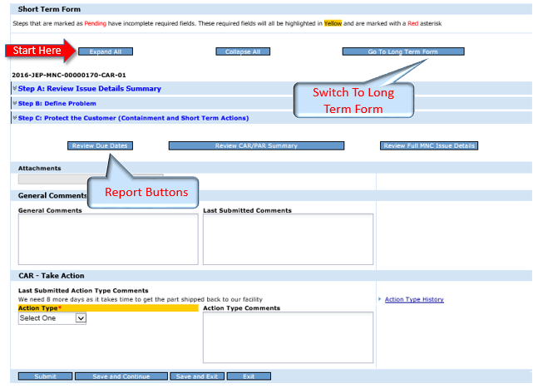

### Areas and Features of the ST Form

### Taking a closer look at the form, you’ll notice that the top of the ST form has three buttons: Expand All (expands all 3 collapsible sections – Step A, Step B, and Step C), Collapse All (Closes the steps) and Go To Long Term Form (acts as a shortcut to the LT form, but you can still access the LT from the My CAR/SCAR/PAR section on the CAR/SCAR tab as normal). Also note that the Issue ID is present just below the buttons for easy reference.

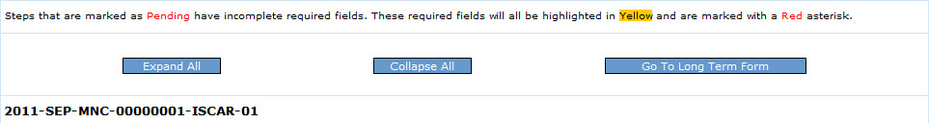

### The most important part of the ST form is the collapsible section area because it represents all of the work that you need to complete as the Respondent. Of the three steps, you can tell that Step A has no required fields in it because the text is displayed in blue and does not have the word (Pending) at the end. Once you complete all mandatory fields in a step and move outside of the step, the system turns the step text blue and removes the word (Pending). That way, every time you bring up this particular form, you’ll be able to see at a glance if you still have pending work. Later in this section, we’ll discuss each step in more detail.



The next areas are the report buttons, Attachments, and General Comments.

* The Review Due Dates button displays a report containing all of the due dates for not only the ST and LT parts of the SCAR, but also for the MNC or PNC that the SCAR is based on.
* The Review SCAR/SPAR Summary is really only useful after the entire SCAR has been complete, such as when you are looking back at this SCAR several months in the future. At this stage, it doesn’t contain any information because you haven’t done any work yet.
* The Review Full MNC (or PNC) Issue Details report displays all fields available in the non-conformance. It is more comprehensive than Step A, as you’ll learn below.
* Contact Details displays the name, email, and phone number (when available) of the Cummins ST contact (the SCAR Approver) as well as the LT contact (the Corporate / Purchasing SQIE). It also displays your information and the information of anyone else in your organisation who has been assigned this SCAR to work.

As you learned in section 3 above, you can use the Attachments area to attach any supporting files, such as spreadsheets or pictures that you deem necessary. Again, all file types are attachable, and in any size. By clicking on the Browse button, you may attach multiple files, but you must do so one at a time. Once an item is attached successfully, you will notice a small letter “x” on the right side of the file name. Clicking this “x” will delete the attachment. An audit trail is kept for all activities. If there is an attachment, the next person to view the ST form will see a hyperlink to the Attachment History Report, where this trail can be reviewed. Of course, you will be able to view any previously attached files as well.

Any text you type in the General Comments area will become visible to Cummins as well as anyone else who is able to view the issue. There is also an area that will display whatever comment was most recently made, if any. Finally, similar to the Attachment area, you will be able to see a hyperlink to the General Comments History Report that displays the audit trail.

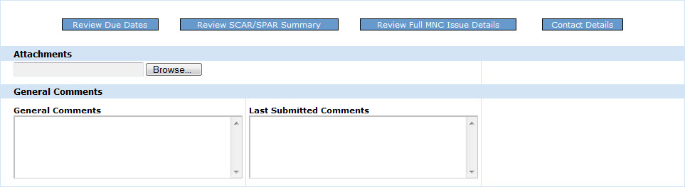

The last part of the ST form is the *Take Action* area. This is where you can dispute the issue, request more time to complete it, or send it for approval when all of the fields in the collapsible sections have been filled out.

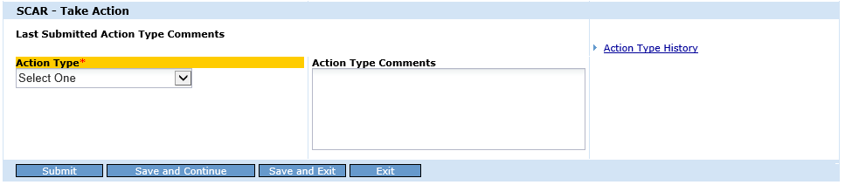

### Disputing the ST or Requesting More Time

When Cummins issues a SCAR to you, it is of course assumed that you are the correct supplier. However, mistakes can and do happen upon occasion. If you feel that this SCAR has been assigned to your company in error, you can use the Take Action area to dispute it. Other times, the issue may indeed be yours, but you may feel that you need more time to complete the ST because the default due date of 48 hours is too restrictive. In this case, you can request more time.

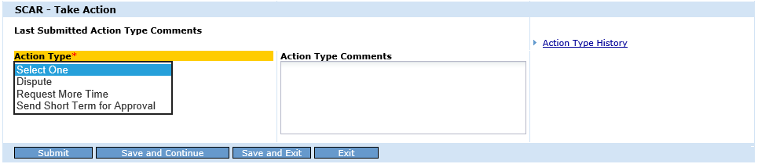

If you select **Dispute**, then the *Action Type Comments* field becomes mandatory. However, no other fields on the form will be mandatory. This will make it easy for you to tell Cummins that you believe the SCAR to be an error. When you click the **Submit** button, the entire SCAR is disputed. CQMS-MetricStream will send the approving Cummins user (known as the SCAR Approver) an email alert informing them of your disagreement. The SCAR Approver also receives an assignment and until they respond to that dispute, you will have no other action to take in the ST. The SCAR Approver may choose to Accept or Reject your dispute. If they Accept, your assignment will be taken away and your responsibility will be removed. If they Reject, then you will receive an email alert and the assignment comes back to you.

If you select **Request More Time**, the *Action Type Comments* field also becomes mandatory. The intention of course is to allow you room to explain the reason for your request. No other fields are required. When you click the **Submit** button, it is a request for more time ONLY in the ST form. CQMS-MetricStream sends the SCAR Approver an email alert and an assignment. Again, until the SCAR Approver responds, you have no other action to take in the ST. The SCAR Approver may choose to either Grant or Deny your request. In either case, you will receive an email alert and the assignment comes back to you with either a new date or the original due date still in play, respectively.

### Step A: Review Issue Details Summary

Step A allows you to review the key details of the non-conformance that the SCAR is based on. You may click on the Review Full MNC (or PNC) Issue Details button if you need more complete information. Most of the time, you will only use this step as a reference, but there are two fields that you can make changes to. Both fields are optional.

The first field is Additional Issue Details Comments. If you have more information specifically about the non-conformance, you should enter that information here. The General Comments field toward the bottom of the ST form is for non-issue-related comments.

The second field is Six Sigma. If you are working with a Cummins partner on a related Six Sigma project, then you may select Yes. You will use the Free Text field to manually enter the Belt Name.

Here is an example of Step A when it is expanded (the data shown is test data and is not real):

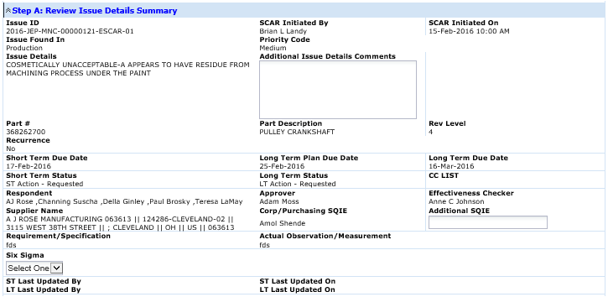

### Step B: Define Problem

Step B, which is a mandatory section, is used to categorize the SCAR at a high level even before a detailed root cause analysis is completed. As shown below, there are five mandatory questions that you will need to complete. Each question is a text field that accepts up to 4,000 characters so that you can be as detailed as you would like.

Tip: Remember that once you complete the required fields in this or any other step, and then click outside the step, the step itself turns blue and the word (Pending) is removed, indicating that the step is no longer mandatory.

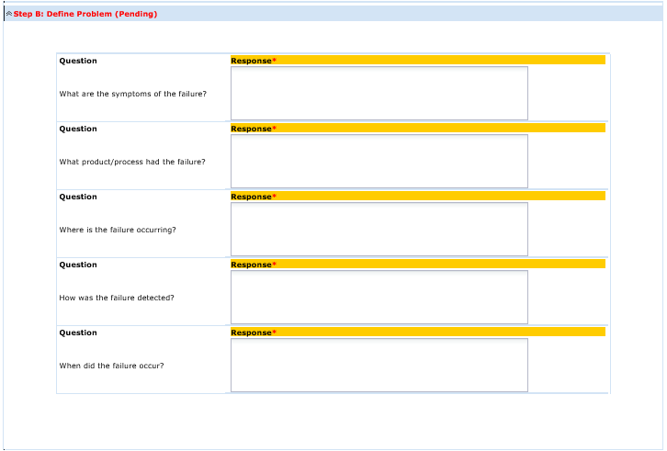

Tip: On this and other sections within CQMS-MetricStream, you may notice two vertical scroll bars. The outer scroll bar is used to scroll the entire form up and down, whereas the inner scroll bar only scrolls the step up and down without moving the form itself.

### Step C: Protect the Customer (Containment and Short Term Actions)

Depending on whether the SCAR in question is from an MNC or a PNC, you will see different fields appear in this step. The PNC version is quite simple and is shown here:

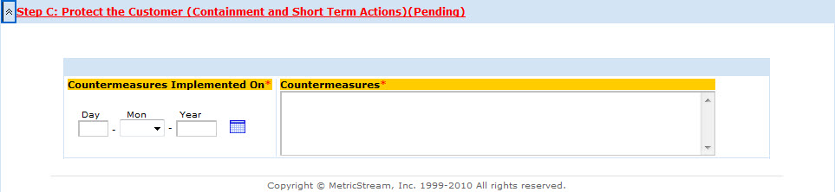

As you see, there are only two mandatory fields – *Countermeasures Implemented On* and *Countermeasures*. One thing to note is that the system does not allow you to enter a date greater than today – you may only record containment that is already complete.

The MNC version is a bit more complex. The top portion is similar to the PNC, but there are many additional fields below that list all of the sorting locations where you may perform containment actions. Each optional sorting location has a Sorted? field that defaults to No:

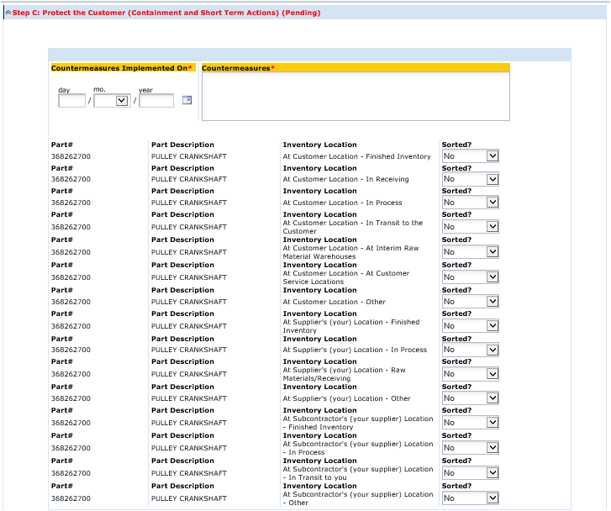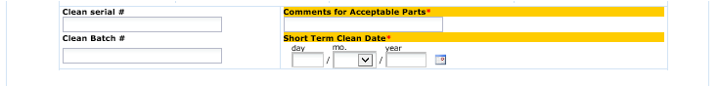

There are several columns of information here: *Part #*, *Part Description*, and most importantly *Inventory Location*.

If you choose **Yes** in the Sorted? field for a particular location, four new mandatory fields appear – *Sorted Qty*, *Defect Qty*, *Sorted By* and *Sort Completed On* as seen in this example:

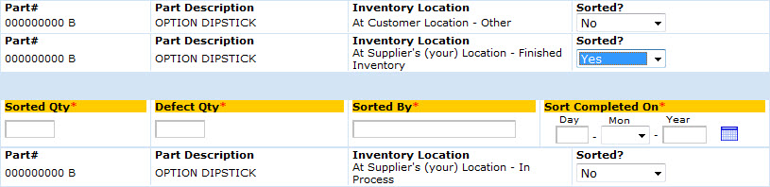

Your responsibility is to complete the sorting details by selecting **Yes** for each location that applies to your situation.

Tip: Notice that some of the 15 locations are defined at the Customer Location (your customer is Cummins), some are defined at the Supplier Location (you), and some are defined at the sub-contractor.

Once you have completed the sorting, there are two more mandatory fields and two more optional fields at the bottom of the step C area. *Comments for acceptable parts* and *Clean Date* are required and are shown on the right hand side of the screen. *Clean serial #* and *Clean Batch #* are optional and are shown on the left.

### Submitting the ST Form for Approval

Once you have completed all of the mandatory fields in steps B and C (and filled out any applicable optional fields as well), you are able to select **Send Short Term for Approval** from the *Action Type* field in the Take Action area at the bottom of the form.

Then, after you click on the **Submit** button, you will see a confirmation screen similar to this:

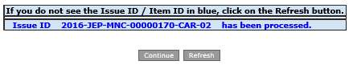

Tip: Rarely, when the confirmation screen appears, you will not see the actual Issue ID as in this example. If you do not see the Issue ID, you should click on the Refresh button instead of Continue. Continue will take you back to the *MNC/PNC* tab. If you need to work on more SCARs, you’ll need to click on the *CAR/SCAR* tab to proceed.

The Cummins SCAR Approver now receives an email alert and an assignment. The *ST Status* column in the *My CAR/SCAR/PAR* section for this issue now changes to “ST – Submitted for Approval”. The Cummins SQIE also receives an email alert, but not an assignment. Unless the SCAR Approver rejects your submission back to you, your ST responsibility is now complete.

1. After you submit the ST for approval, don’t forget that you will still have to complete the LT assignment in order to complete your response to the SCAR.

## Completing the LT Form

In CQMS-MetricStream, the *LT* form has 6 steps: *Review Issue Details Summary*, *Identify* *Long Term Plan*, *Identify* *Root Cause Analysis*, *Record* *Action Items*, *Summarize* *Permanent Corrective Actions,* and *Identify Similar Processes Where Fix Can Be Applied.*

In many ways, the LT form is similar to the ST form that you learned about above. Similar to the ST form, the LT form has options for you to dispute or request more time by selecting the appropriate *Action Type* and clicking the **Submit** button at the bottom of the LT form in the Take Action area. These actions act in the same way that they did under ST.

Reminder: CQMS-MetricStream allows you, the Respondent, to complete both the ST and the LT at the same time. This is a nice feature for fast and easy corrective actions – you don’t have to wait for ST approval before moving on to LT.

There are other similarities as well, such as the Expand All and Collapse All buttons, the report buttons, and the Attachments and General Comments areas.

However, the LT form does contain many key differences from ST:

1. The steps. There are 6 steps in LT as compared to 3 steps in ST and the steps are significantly different. We’ll go over each step in greater detail shortly, but here’s what they look like:

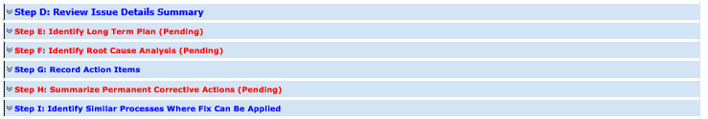

1. The due dates. There are two type of LT due dates, where ST only had one. You might recall that the default due date for ST completion was 2 calendar days. For LT, the due date for LT completion (also called the *Long Term Due Date* or SCAR Due Date) is 30 calendar days from SCAR initiation. Additionally, there is another LT date called *Long Term Plan Due Date*. This is 10 calendar days from SCAR initiation, and you’ll learn more about it in Step E below.
2. The approval process. In ST, when you submit the form to Cummins, it goes to the SCAR Approver immediately. In LT, however, your submission goes to the Cummins Corporate / Purchasing SQIE for final approval.

### Step D: Review Issue Details Summary

Step D is identical to step A on the ST form. It contains all the same information.

### Step E: Identify Long Term Plan

As is stated on Step E itself, the Long Term Plan is an opportunity for you to communicate your commitments to various milestone dates within the corrective action process, even before you complete the root cause analysis.

This is a mandatory step, and there are three parts to it.

* The first part, Short Term Summary, is for your information. If the ST has been submitted for approval, then the answers to the questions “What are the symptoms of the failure?”, “What product/process had the failure?”, and “How was the failure detected?” are provided as a quick reference so that you do not have to go back to the ST Form. If the ST Form has not been submitted for approval, you will not be able to view the answers as shown in the example below.
* The second part is the Team Members section. CQMS-MetricStream defaults the first team member to you as the Team Leader. It also lists the second team member automatically as the Cummins Corporate Purchasing SQIE and third team member as the Cummins SCAR Approver. You may optionally use the Add Member link to include additional team members as necessary. You are required to fill in the *Function* field for each member. This field defines what work area team members are from, to help ensure a good cross-functional team.
* The third part, Milestone Dates, is where you record your committed dates and notify Cummins once they’re filled in. The dates are for when you project that your root cause investigation will be completed by, when you project that you will both identify and implement the permanent fix, and when documents such as the FMEA will be updated by. Cummins understands that at the end of the SCAR, that these dates may not reflect the dates that things really happened. However, at this stage, these dates signify that you have thought about the issue thoroughly and at least have a plan in place. You may also enter any comments specifically about the plan in the optional field. **ALL Dates** in this section **MUST** fall between the **SCAR Initiated Date and the LT Due Date**. If you think you need more time than the LT Due date already given, you need to request more time by Selecting the Action type **Request More Time**

Once you have filled in the Team Member and Milestone Dates, you are ready to click the **Notify Cummins of Completed Plan** button. This button sends an email alert to the Corporate / Purchasing SQIE and the SCAR Approver, as well as other related Cummins users informing them of the completion. Once you click on this button, all fields on this step become read-only and cannot be edited, and you are free to move on to the next steps on the LT form.

1. You have 10 calendar days from the date the SCAR was sent to you to complete the long term plan and click the **Notify Cummins of Completed Plan** button. Unlike the ST and LT submission dates (2 and 30 days respectively), you cannot request more time for completing the plan. If you do not click the button, emails will be sent advising Cummins of the past due status. There is no system Approval or Rejection associated to the LT Plan.

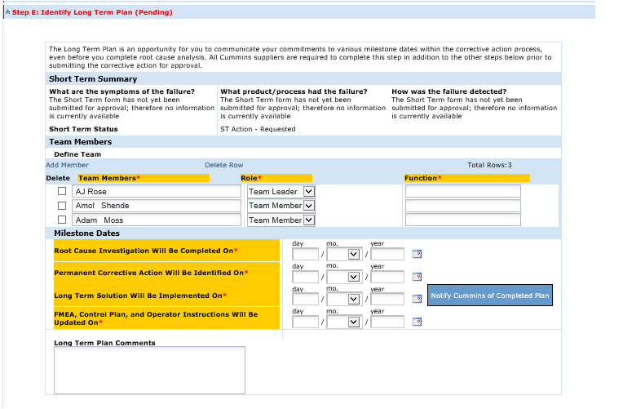

### Step F: Identify Root Cause Analysis

It is important to understand that CQMS-MetricStream was not designed as an actual analysis tool. It was designed as the place to document the results of that analysis. Analysis tools such as 3P, 5 Why, and Fishbone are frequently used. If the Cummins facility or facilities that you supply to do not have required standards, then you may use any tool you wish.

Whichever tool(s) you use, you should attach them in this step. Although there is an Attachments section towards the bottom of the LT form, the attachment area in step F is specific to root cause analysis.

Underneath the attachment box, there are several blank templates provided as document links. If you wish you can open these templates, save them to your local computer and fill them out. After that, you may attach them. The link called “SCAR work sheet” must be completed for all Cummins Engine Plants that raise the SCAR against you.

The main part of step F, however, is the set of three questions and Root Cause? drop down lists that follow. Each of the three questions is required. Question 1 is “Prevent - Why did the creation (manufacturing) process not prevent the specific defect or issue”, Question 2 is “Protect – Why did the control and containment processes not protect the customer from the defect or issue?”, and Question 3 is “Predict – Why did the planning process not predict the defect or issue?”. Your detailed answer to each of these questions is a critical key to the eventual success of the SCAR.

Each question also has a required drop down field that allows you to choose the best Root Cause. Examples for Question 1 are “Broken Tool” or “Gauge Not Calibrated”. An example for Question 2 is “Detected Product Was Released in Error”, and an example for Question 3 is “Control Plan Inadequate”.

The final two fields’ show who was the last Respondent to save work on this step. If multiple contacts at your company are working the LT Form, these fields can be very useful.

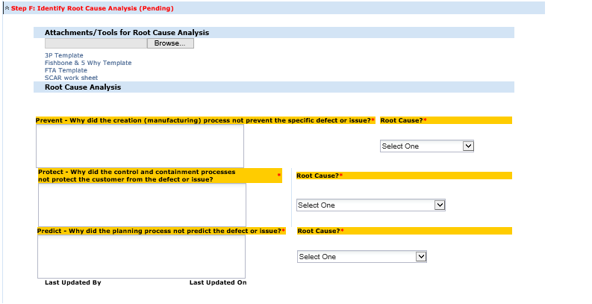

### Step G: Record Action Items

After you complete your root cause analysis, there will of course be actions that either you or your team will take as a result. Although this technically is an optional step, these action items should be recorded here. When you first open the step, here is what you will see:

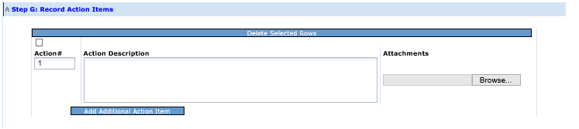

As soon as you type in the Action Description (where you explain the details of the action taken) and click or tab outside the field, you will see several changes to the step:

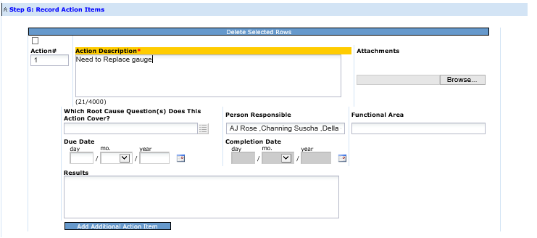

Now, the Action Description field is mandatory (which makes no difference to you, because you just typed in the details). Additionally, there are several optional fields which have now appeared.

The first field is “Which Root Cause Question(s) Does This Action Cover?” Any action item that you or your team take should relate directly to at least one of the root cause questions you learned about in step F above. When you click on the icon on the right, you’ll see the following pop-up window. Here, you may select one or more of the questions that this action item applies to:

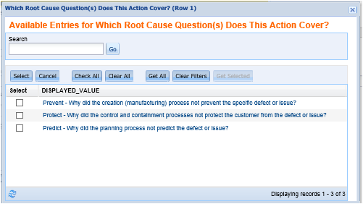

The Person Responsible and Functional Area fields help you to designate who is doing the work for this particular item. The Due Date and Completion Date fields are optional, but useful for looking back at the SCAR summary after completion. The Due Date field may also help you to track outstanding work. The Results field is really the most important even though it too is optional. Again, filling out this field with an appropriate level of detail will be very useful when someone outside of your core group looks at the SCAR.

Using the **Add Additional Action Item** button, you may post as many items as is necessary to facilitate the permanent fix for the root cause. You may of course delete items as well.

### Step H: Summarize Permanent Corrective Actions

Once your root cause analysis and action items have been completed, the final mandatory step is to record a summary of what you’ve accomplished. It doesn’t matter if the SCAR is MNC-based or PNC-based, all seven mandatory fields are mandatory and will display as you see here:

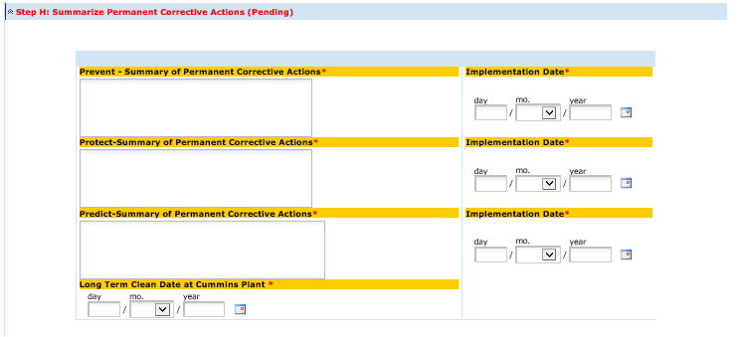

The implementation dates for “Prevent” & “Protect” Summary of Permanent Correct Actions must be todays date or a date in the past. The Implementation Date for “Predict” Summary of Permanent Corrective Action and the Long Term Clean Date can be future dates.

Tip: Put as much detail as you can in the Summary of Permanent Corrective Actions fields. It will help you and Cummins in terms of searching if it becomes necessary down the road. It also is helpful when you are looking for repeat issues.

### Step I: Identify Similar Processes Where Fix Can Be Applied

Step I, while it does not have any required fields, can be a very helpful tool. You can use it to record processes and locations where the permanent fix can (and probably should) be implemented. You can also use it after those applications have been completed to record the effort and provide a documented trail of activity.

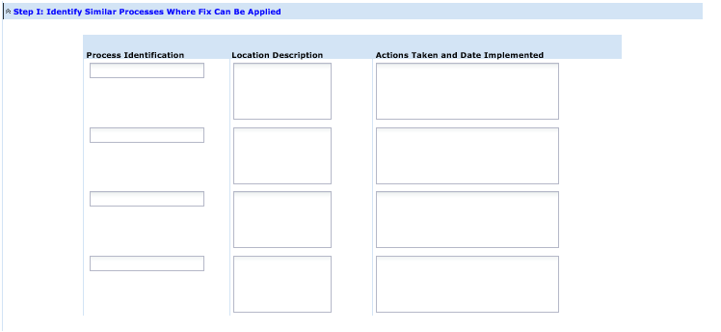

### Submitting the LT Form for Approval

Once you have completed all of the mandatory fields in steps E, F, and H (and filled out any applicable optional fields as well), you are able to select **Send Long Term for Approval** from the *Action Type* field in the Take Action area at the bottom of the form.

Then, after you click on the **Submit** button, you will see a confirmation screen similar to this:

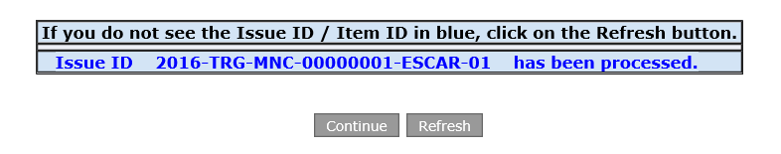

Tip: Remember that occasionally, you will not see the actual Issue ID as you do in this example. If you do not see the Issue ID, you should click on the Refresh button instead of Continue. Continue will take you back to the *MNC/PNC* tab. If you need to work on more SCARs, you’ll need to click on the *CAR/SCAR* tab to proceed.

The Corporate / Purchasing SQIE now receives an email alert and an assignment. Upon their final approval, the SCAR will automatically be sent for Effectiveness Checking.

The *LT Status* column in the *My CAR/SCAR/PAR* section for this issue now changes to “LT – Submitted for Approval”. Unless the Corporate Purchasing SQIE rejects your submission back to you, your LT responsibility is now complete. Your work as a Respondent is finished for this SCAR.

1. You must submit your LT for Cummins approval within 30 calendar days of SCAR initiation, or the issue will become past due.

# Introduction to Reports

Reports allow you to view your data in a variety of different ways. As you become more advanced in CQMS-MetricStream and more data becomes historical, you will likely want to use these tools more often. For now, we’ll just introduce the basics.

There are several ways to access reports. The first way only applies to some reports, not all. We refer to this way as “inline” reporting. In fact, you’ve already seen several examples of inline reports, such as the *General Comments History Report*, the *Attachments History Report*, and the report buttons on the ST and LT forms. Inline reports are launched from within a form instead of from the *Supplier Reports* main navigation tab, where the standard supplier reports are available.

The second way to access reports is by using the *Supplier Reports* tab directly. The tab looks like this:

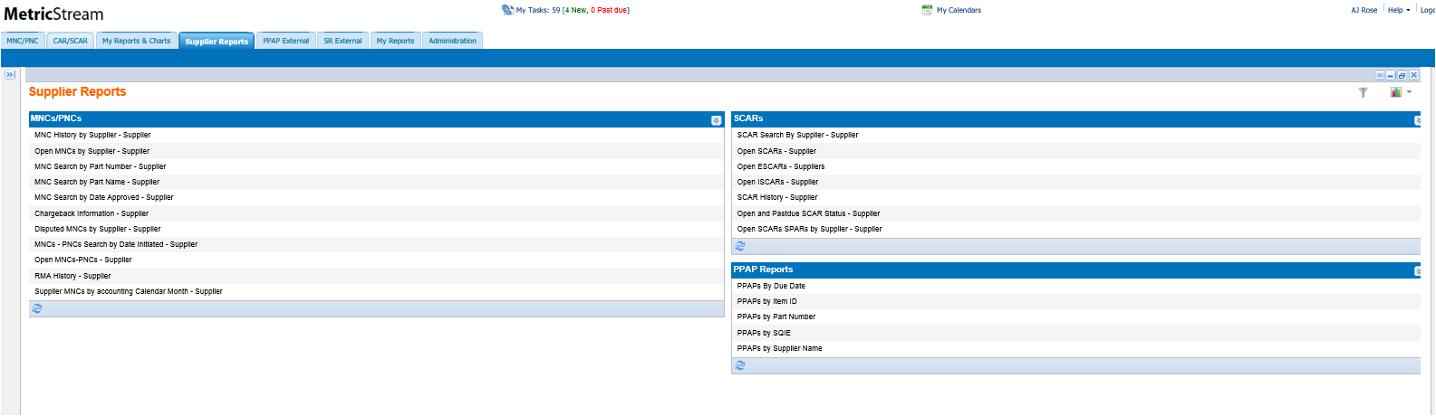

All non-conformance reports are found on the left hand side of the screen and the right hand side contains all supplier corrective action reports. Each of these reports is one of two styles: either a tabular report or a form-based report. As the name suggests, form-based reports look like a CQMS-MetricStream form. Tabular reports look like a spreadsheet, with many rows and columns.

When clicked, most reports will immediately display. However, a few may first take you to a screen where you can enter some parameters (or filters), such as date ranges that help you narrow down the scope of the results. Here is an example from the *MNCs/PNCs Search by Date Initiated - Supplier* report:

In this example there are two date parameters. Once you click on the calendar icon and select a date, you can then click **Submit** to run the report. In this example, CQMS-MetricStream will return all the MNCs and PNCs that were created (initiated) between the dates specified:

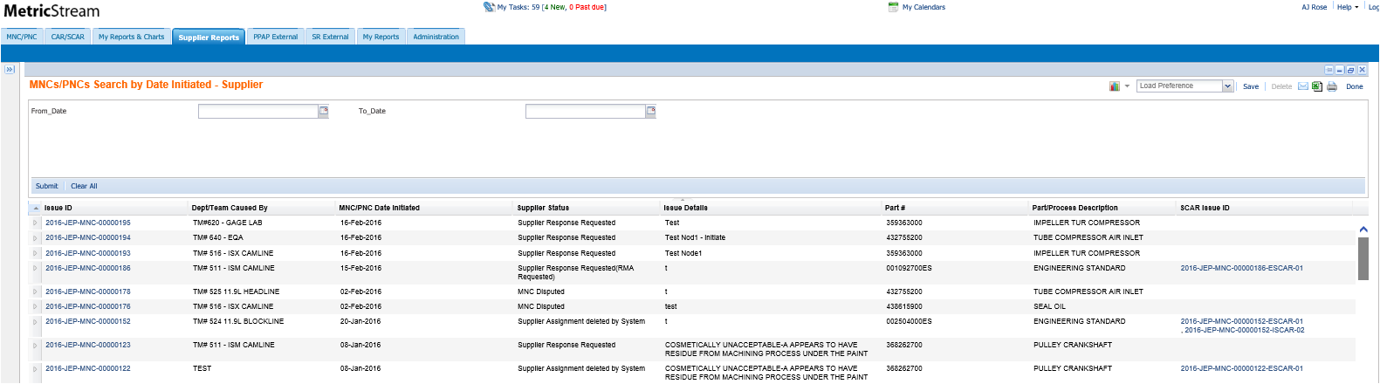

**Submit**

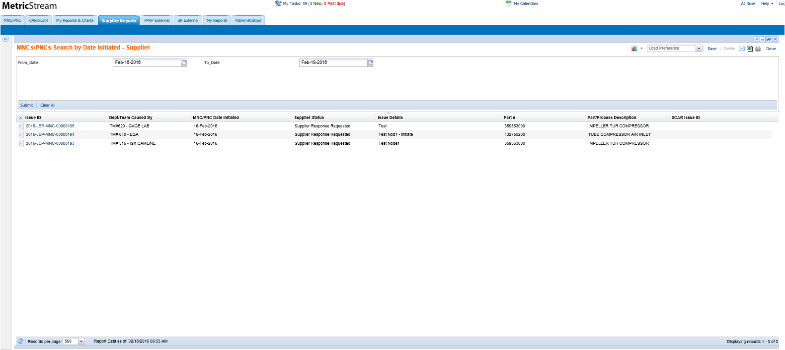

**Submit**

Tip: When you launch a report from *Supplier Reports*, if the parameter window appears, you must complete all mandatory parameters before clicking **Submit**. The red asterisk (*) indicates if the parameter is mandatory.

There is actually another method to access some reports: through the *My Reports & Charts* tab. The *My Reports & Charts* tab has been superseded by the *Supplier Reports* tab (in fact the reports on the *Supplier Reports* tab run much more quickly).

### Tabular Reports

Tabular reports look and act similar to a spreadsheet. That is, you can click on any column to sort the data, and click again to reverse the order.

In fact, you can actually export tabular reports to Microsoft Excel and on to Minitab or other statistical software for further data analysis. You can also print the report (although with many rows and columns, it is often easier to print through Excel), or email it to any email address.

1. Remember that it is against Cummins policy to send unencrypted restricted or confidential data through email. Please refer to your supplier agreement for more details.

Take a look at this sample SCAR History -Supplier report:

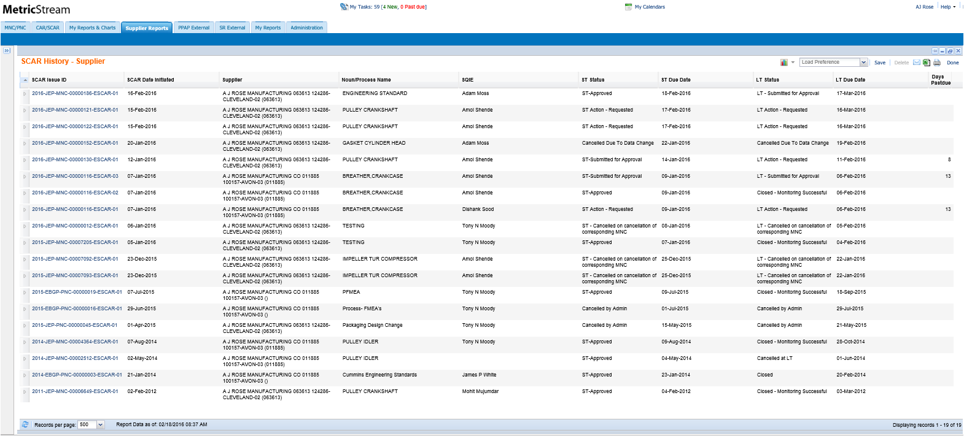

You may notice that the SCAR Issue ID field has hyperlinks. This indicates that you can “drill down” into each issue. In this case, clicking on a SCAR Issue ID drills down into the SCAR detailed report (Form Report). In fact, many reports drill down to other reports.

### Form Reports

As stated earlier, form reports look just like forms. For example, if you click on the **Review Full MNC Issue Details** button on the ST or LT SCAR forms, you will see something like this:

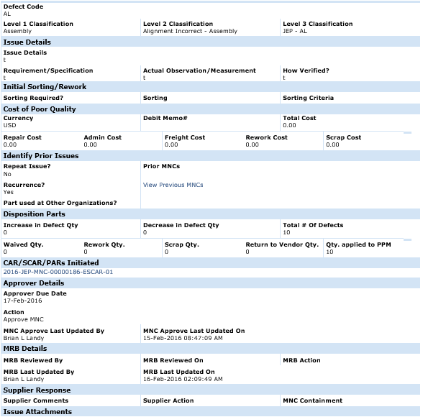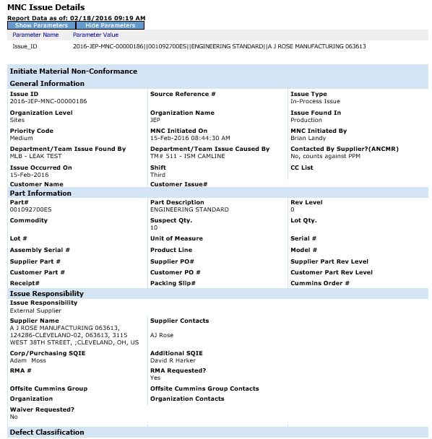

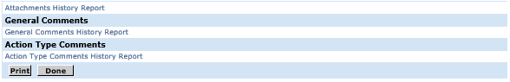

# How to Get Help

At first glance, the CQMS-MetricStream application can seem quite complicated. Cummins is confident that once you begin using the tool, however, you’ll be able to use it easily and effectively.

Nevertheless, you may certainly find that you need help with a question or you need to look up a reference document if you find that you’ve forgotten a key point. For that reason, Cummins provides several tools for you. The first is this document. It is a good idea to check to make sure you have the latest version by visiting the website below.

Please review the following table, which lists several avenues you can use to get help. They are listed in the order of most commonly helpful to less commonly helpful.

|  |  |  |
| --- | --- | --- |
| Tool | What It Does | How To Use |
| CQMS-MetricStream Learning Center | Provides this guide, as well as other documents and references. | From any Internet computer (you don’t have to be on the Cummins network), type this address in your browser:  cqms.cummins.com/training/training.html  You can also find a link to this website on the Global Supplier Portal. |
| Your Cummins SQIE(s) or Sourcing Manager(s) | This is the Cummins person or people that you work with at the plant. | Email or telephone where applicable. You may have this info already, but you may also use the *Contact Details* button on the ST or LT SCAR forms as well. |
| Email Cummins Supplier Portal Team | This is the group of people who will be able to help with Supplier Portal. | Please email [supplier.portal@cummins.com](mailto:supplier.portal@cummins.com) with details related to your Supplier Portal issue. Please provide screen shots and an explanation of what you were trying to do along with the date and time the issue occurred. Please Note – this group only supports Supplier Portal and not CQMS Metric Stream. |

This concludes this training guide. We hope that you’ve found it informative and clear. We look forward to continuing to partner with you in continually improving the quality of Cummins products. Thank you for your time!