SCR Form
On the PPAP External tab in the My Forms area, you will see a link titled Create New Supplier Change Request (SCR), similar to this:
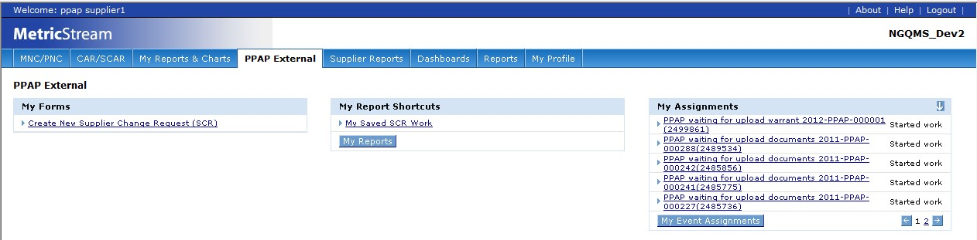

As you would expect, clicking this link opens up the SCR form and allows to you to initiate an SCR.
You may also access an SCR that you have already started but have not yet submitted to Cummins by using the My Saved SCR Work report which is found in the My Report Shortcuts area in the middle of the screen.
Underneath the My Related PPAPs area, there is another area called My Related SCRs (you may have to scroll down to see it). It looks something like this:
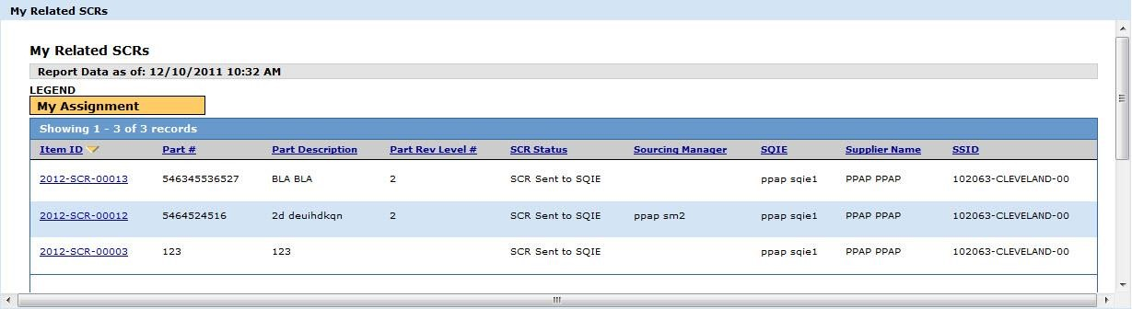

As you can see, My Related SCRs is similar to My Related PPAPs in several ways. First, both contain a great deal of information that you can see at a glance about your PPAPs or SCRs. Second, both only display open items (once a PPAP or SCR is closed, it will no longer appear in these areas).
When you click on the Create New Supplier Change Request (SCR) link, the SCR form opens.
You’ll notice that it has the same general look and feel as the PPAP Supplier Response form, but there are a couple of differences.
The SCR form contains two collapsible sections – General Information and Approvals. The PPAP Supplier Response form had five sections. Also, the SCR form has a General Comments section, where you can communicate with Cummins without attaching a file.

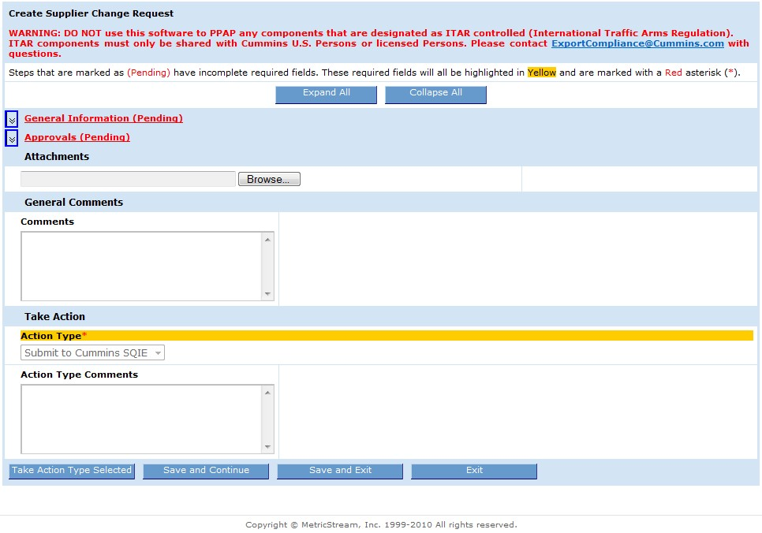
Warning: Please pay special attention to the warning at the top of the SCR form regarding International
Traffic Arms Regulation) ITAR and regulatory compliance. You must not use CQMS-PPAP (MetricStream) to PPAP any components designated as ITAR controlled. ITAR components must only be shared with Cummins U.S. Persons or licensed Persons. You should contact ExportCompliance@cummins.com with any questions.

In the General Information section, seen below, you will enter information related to the SCR such as Part Number (both yours and Cummins) and the description, purpose, and benefit of the requested change. Remember that you are required to fill in all of the fields highlighted in yellow with the red asterisk. All required information should be obtainable from functions and information sources within the Supplier Organization (i.e., Sales & Marketing, Engineering, Quality, Manufacturing, etc.).
NOTE: When submitting an SCR for a ‘Family’ of parts, please use the following guidance for these attributes:
Cummins Part Number - List all part numbers in sequential order separated by a comma (i.e., 5648555, 5792110, 5443209, …., etc.).
Supplier Part Number - List all part numbers in sequential order separated by a comma (as was done for the Cummins Part Number entry), ensure that they line up with the Cummins part number sequence.
Part Revision Level Number - Following the same rule as applied to the part numbers, above, list the Revision Level for the parts in sequential order, separated by a comma and ensure they line up with the part number order.
Current and New Cost Per Piece - use the average weighted cost for all affected parts and enter this value in USD ($).
Annual Volume - enter the total cumulative volume for all parts affected.
Max Lead-Times (Tooling and PPAP entries) - Enter info for the part with the longest lead time.
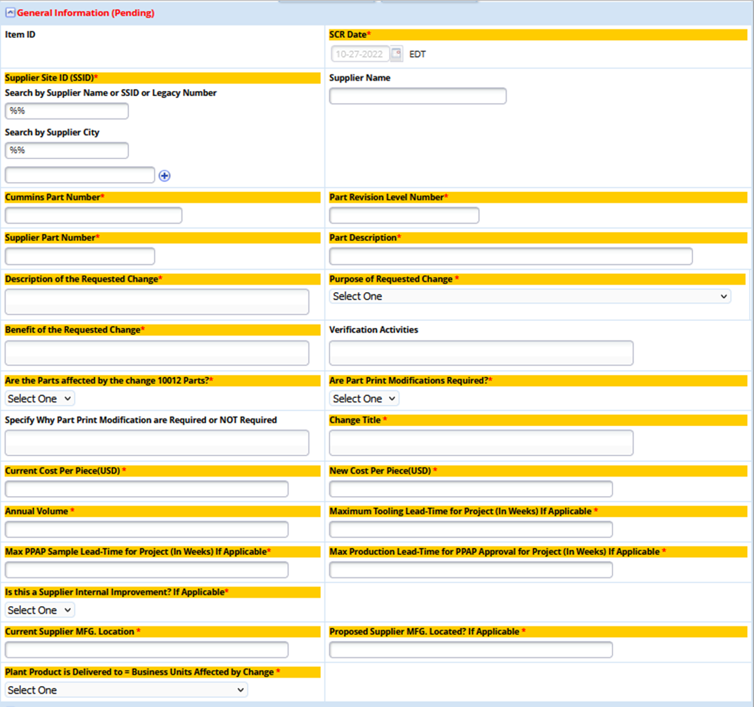
The Approvals section is where you select the Cummins SQIE and SM (optional) for SCR approval:
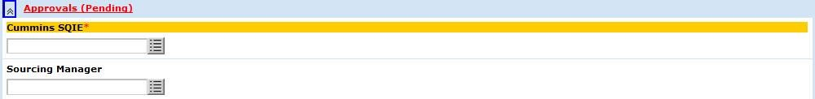

Underneath the collapsible sections are the Attachments and General Comments section. You may attach one or more files for Cummins view and make any comments you wish. A history is maintained for both.
Finally, at the bottom of the form, the Take Action section gives you only one choice in the Action Type field, which is “Submit to Cummins SQIE”.
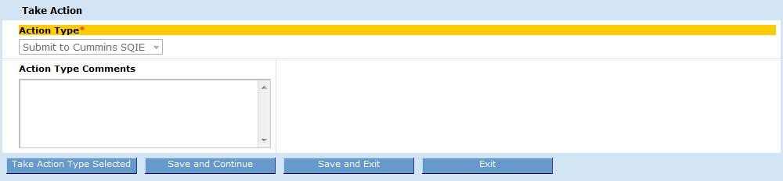

In this section there is also an Action Type Comments field. For SCRs, it is recommended that you enter comments in the General Comments section and not in this field.
The buttons at the bottom of the form are the same as in the PPAP Supplier Response form:
- Take Action Type Selected – submits the SCR form to Cummins for approval.
- Save and Continue – saves your work (a good idea, especially if you need to take a break from your computer for a short time) and leaves the form open.
- Save and Exit – saves your work but closes the form. This is useful if you are not going to be using the system for an extended period of time, such as if you’re going to lunch or leaving work for the day.

Warning: Clicking on Save and Continue or Save and Exit does not submit the SCR to Cummins. You
must use the Take Action Type Selected button.

- Exit – does not save your work, but simply closes the form. A warning will appear reminding you to save if you haven’t done so already. You will be taken back to the MNC/PNC tab.

If your SCR is rejected by Cummins, you will get an email notification. However, if your SCR is approved, then a PPAP is created by the Cummins SQIE according to the workflow above.

