Source Release
Click on the “SR External” tab.
A screen like the one below will appear.
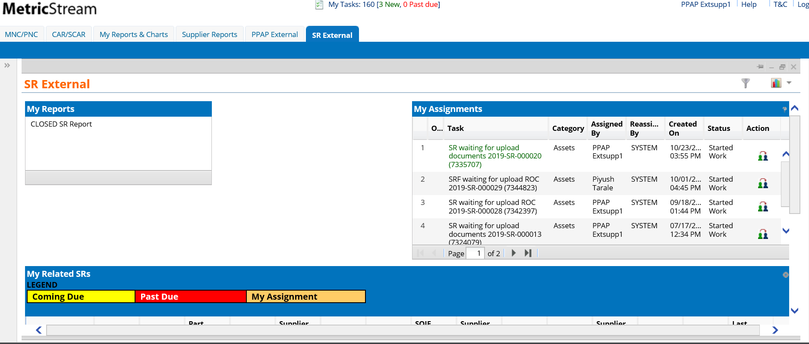
By using either the My Assignments area or the My Related SRs area on the SR External tab, you will be able to find and click on the SR you wish to see.
When you do so, the system will open the SR Supplier Response form, as you see here:
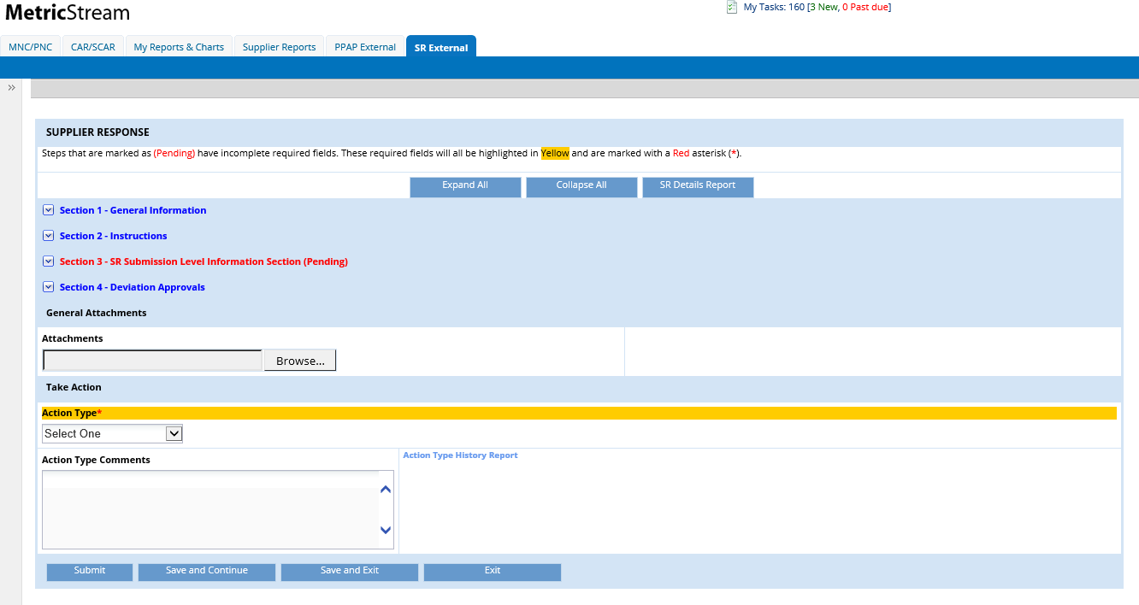
At the top of the page, there are several buttons which are common to most CQMS (MetricStream) forms. First, the Expand All button simply expands all the sections together while Collapse All does the opposite. Next, the SR Details Report button allows you to view all of the details of the entire SR.
Beneath these buttons is the collapsible area. This is where you will do the majority of your work.
- Section 1 displays some general information about the SR, including the Item ID (if you’d like to view more information about the SR than what you see in this step, use the SR Details Report button).
- Section 2 displays a link for Supplier Instructions. If you are new to the CQMS (MetricStream) system, it’s recommended that you read these instructions carefully.
- Section 3 is where you will upload the SR documents if requested by the SQIE. The document elements that are requested by Cummins will be highlighted in yellow.
- Section 4 is the deviation approvals. This is for use by Cummins only.
- General Attachments is available to upload any extra documents requested or documents that will be helpful for the SR.
- Take Action section is available for the supplier to either Submit Documents or Request New Due Date. There is also an Action Type Comments field that is a free text field that users can add comments.
Step 1: Upload Documents:
Upload all required document in Section3. Additional documents can be uploaded in General Attachments section.
At this time, the user has the option to select “Submit Documents” in the Take Action Section to send the documents to be reviewed to Cummins.
In order to submit the SR for approval, user needs to complete Step2 and 3 below.

Step 2: ROC Submission
Once SR documents have been uploaded in Section 3, the ROC (7. Records of Compliance) can be accessed, completed and submitted.
This is what the ROC looks like:
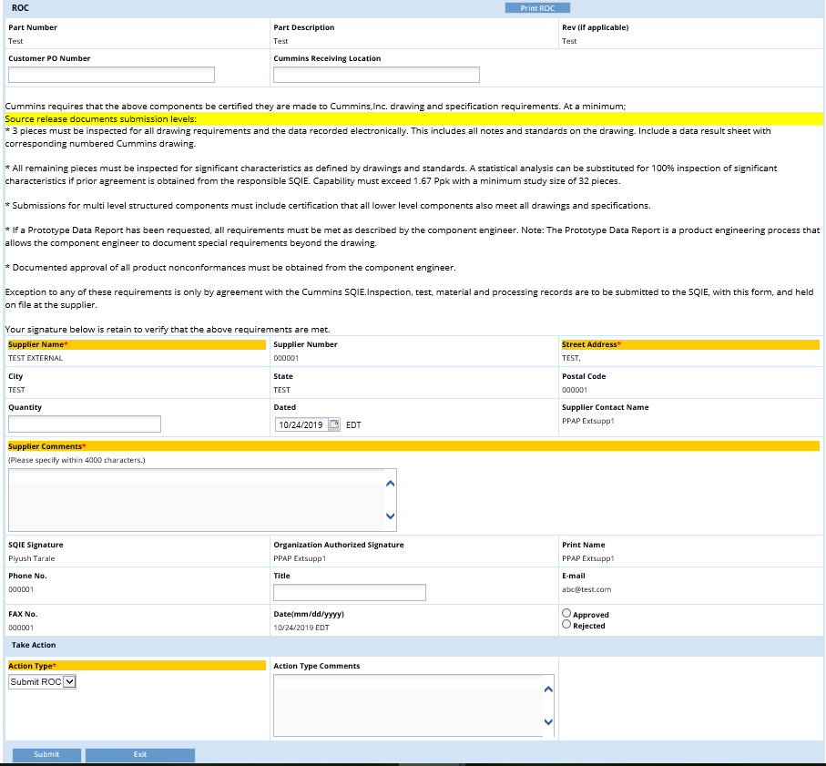

Enter the Customer PO Number, Cummins Receiving Location, and Quantity, if known. Read the verbiage and ensure the supplier conforms to all the ROC requirement listed.
Enter comments in the Supplier Comments section. This is required. Any information from Supplier side to Cummins, including any special comments or instructions should be entered here. If there is no message to be given, the supplier can simply enter "N/A" in the field.
Once complete, click on the Submit button at the bottom of the screen.
Step3: SR submission for approval
Once the ROC is Submitted, the user needs to select Submit Documents within the Take Action section. The user will then click on the Submit button at the bottom of the screen to submit the entire SR to Cummins for approval.

